Alexander Lee
alexander@xenon.blue
ENGR: 112
04/08/2020
Analysis of Hubble Images Using Matlab Octave and the Image Add-on Package
(Stellar Object Detection and Visual Spectroscopy)

Abstract:
Utilizing Octave and the Image add-on various images[1][2][3] taken by the Hubble space telescope were analyzed to obtain a rough estimate of the number of visually distinguishable stellar objects in three images of star clusters. Procured data in the form of x-axis and y-axis coordinates along with an estimate of each stars relative size as presented in the source image measured in pixels. This data was visualized in the form of plotted markers both overlaid upon the source image and with graphs.
Visual spectroscopy was also attempted, with the goal of identifying the presence of significant elements which make up large parts of the composition of various nebula. This data was compared to an identical NASA analyses[4] to compare results.

Body:
For the first part of my project I chose to utilize three large Hubble images and attempted to use Octave to create a count of every distinguishable star in each image. These images were chosen based on their level of detail and the apparent ease with which stellar objects could be distinguished. The first image, the Globular Star Cluster[1] was selected because of its fairly low file size and high density of visible stellar objects (see figure 1).
Initially I attempted to simply convert it into a binary image (consisting of true black and white) and then tried using the regionprops function to identify clusters of white pixels. This did not go well because of the significant blurriness and the light bloom.
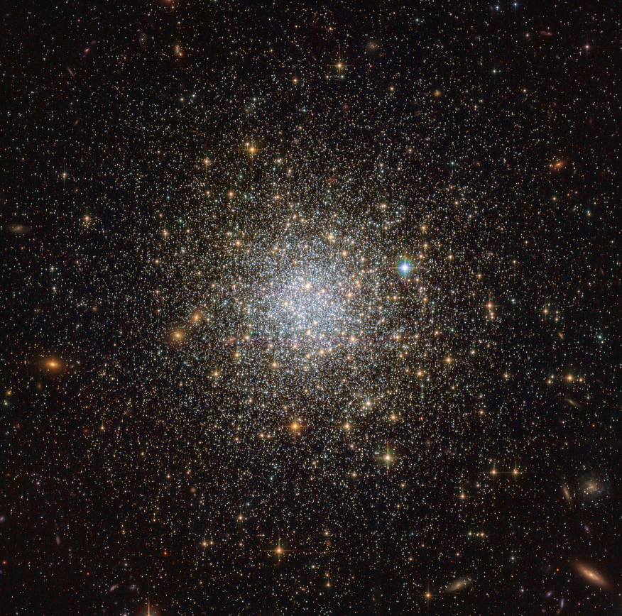Figure 1: Globular Star Cluster
After much research and gluing together of code snippets the image was cleaned up by subtracting amplitudes under a certain threshold. Having done that it was converted to a binary image and regionprops was used to identify the centroids and areas of every cluster of white pixels.
This data was all exported into a spreadsheet containing the x-axis, y-axis, and size in pixels of every identified cluster. For the Globular Star Cluster the number of stellar objects came to 32,967. For the sake of a presentation more interesting than a spreadsheet (who doesn’t like spreadsheets composed of 33k rows of useless data?) I plotted every point over the original image.
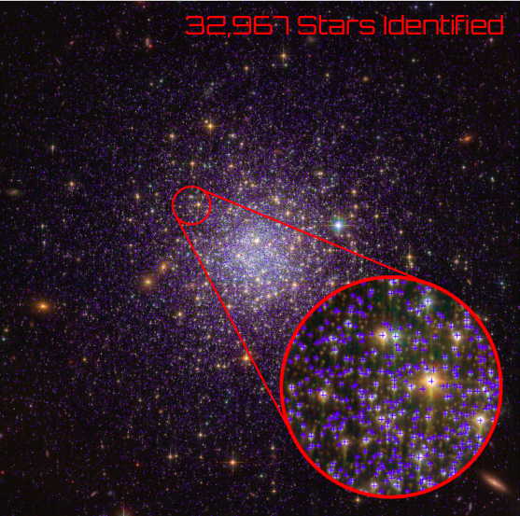Figure 2: Processed And Edited Image
The resulting image, after I figured how how I could produce a high resolution export with the markers all properly aligned, was then edited using external software (Gimp) to show a magnified section in which the markers were actually visible (see figure 2). This would also have been done in Octave however I could find no suitable means of accomplishing this.

A graph was produced comparing object sizes to the number of objects with that size (see figure 3). This graph was noteworthy because of an unexpected spike in star size. This spike in object size was present in some of the other images I tested as well. Figure 3 depicts the graph for the first image and figure 4 shows the graph of another image which also exhibits the same spikes
The exact cause of these sharp spikes in apparent object size are unknown. You may also note that each image does feature some unrealistically large objects. It can be assumed that any objects with a size of over 50 square pixels is an error.
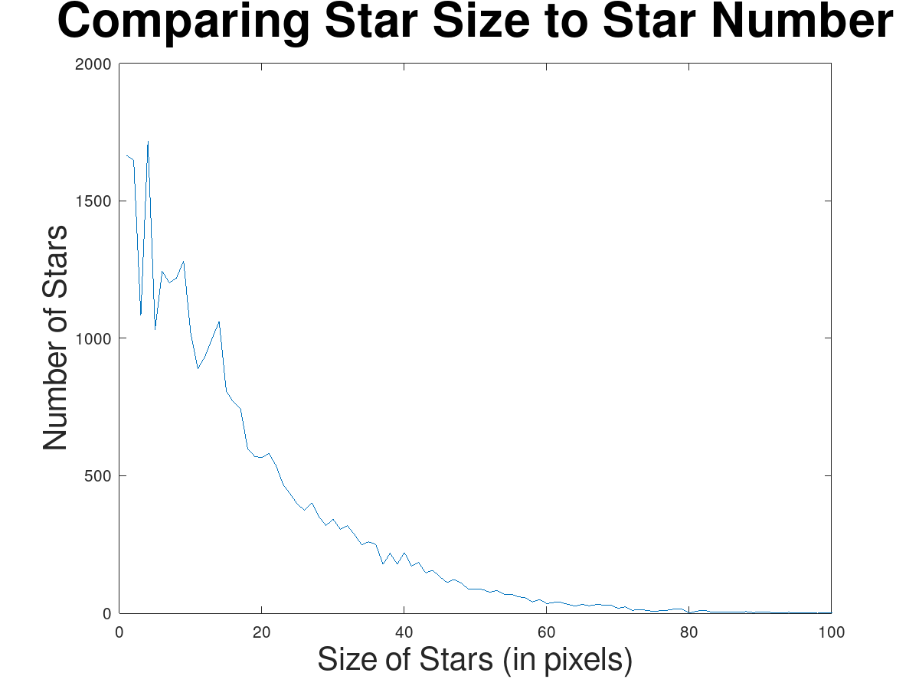Figure 4: Other Star Image used for testing
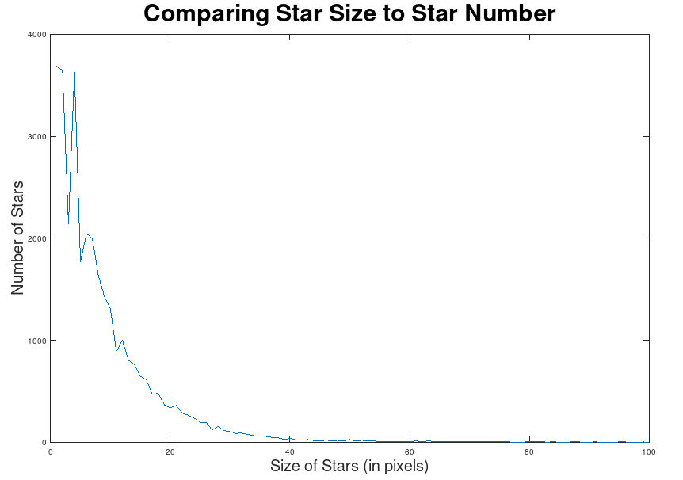Figure 3: Globular Star Cluster Object Size
A 3d scatter plot was also generated displaying the stars with a random z-axis. This was a rather effective visualization tool. I considered finding a way to assign a z-axis such that it would radiate outward in a spherical pattern however ultimately decided it was not worth the time and effort. See figure 5 which displays these plots.
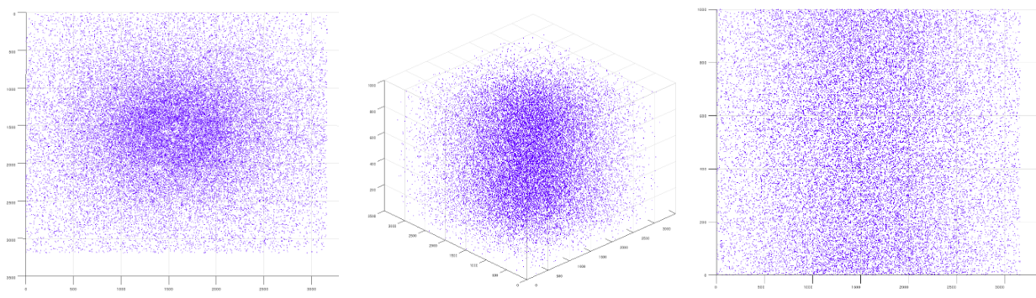Figure 5: Plots from various angles
I also attempted to import a csv of the coordinates into Blender however for some reason it never quite worked. (Would import after about ~20 minutes of complete freeze but with a full quadrant of the objects missing). This was deeply unfortunate as I had wanted to make a panoramic animation of the stars both from the outside and a view from the center of the cluster.
With the goal of seeing just how many stellar objects could be identified from one image I then sought out the largest possible image that I could find. This turned out to be a large stitched together deep field image of the Triangulum Galaxy[2]. I initially tried utilizing the largest format. An incredibly high-res image topping in at 4.4 gigabytes. After many tries and various tweaks I gave up on this image due to its exorbitant ram usage and settled for a lower resolution image which comprised only about 50mb. Even this image required some tweaks to make the program more efficient which included writing images to disk directly instead of displaying them and clearing every possible memory sector once it was not no longer needed. This resulted in a final count of 1.4 million objects distinguished. Side note… apparently Excel is limited to 1 million rows.
Many images omitted from this report in the interest of saving paper and because it seemed pointless to provide only low resolution plots and images. All images are available in the repo for this project.

For the second part of my project I attempted to break a high res image of a nebula and convert it into a wavelength histogram for the purpose of determining the elemental composition of various nebula. The first image selected was a Hubble favorite, the Southern Crab Nebula[3] (see figure 6). This image was selected because of an already existing spectrograph[4] of the elemental composition which I would be able to compare results with.
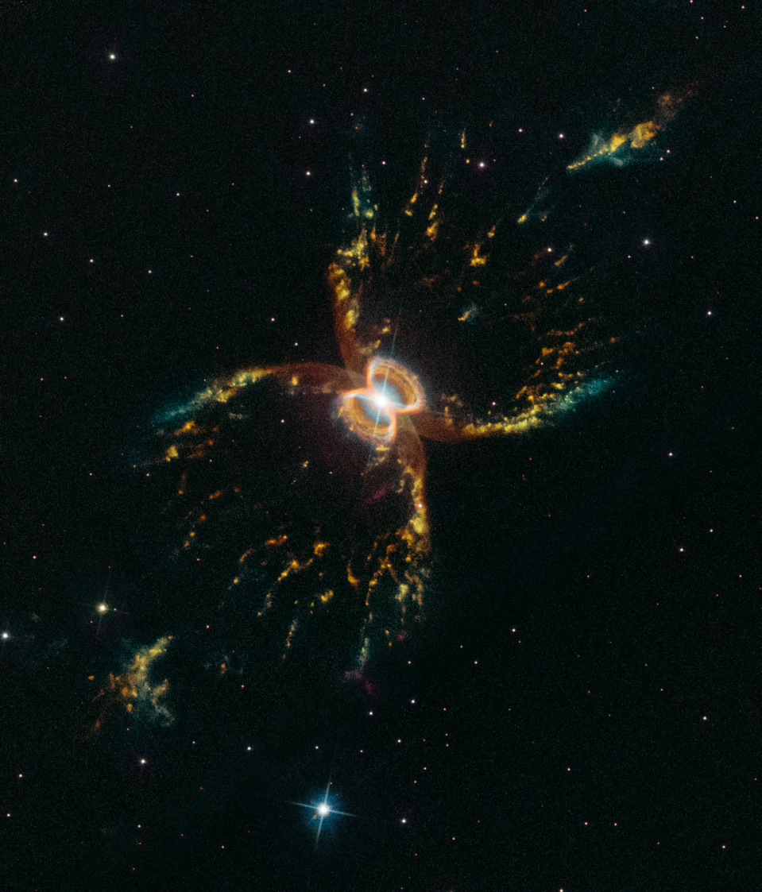Figure 6: The Southern Crab Nebula
To accomplish this goal I first converted the RGB color scheme of the image into an HSV color scheme which was then converted to a 360 degree color palate. After applying a mask to only accept color values with a certain threshold (otherwise black and white regions were throwing it off too much) it was then converted to a wavelength in nano-meters (nm). Final graph is displayed bellow in figure 7.
It should be noted that the entirety of the color mapping part was shamelessly copied, verbatim, from a stackoverflow post[5]. This sharply contrasts the rest of my project, which came from many different stackoverflow posts which were then glued together.
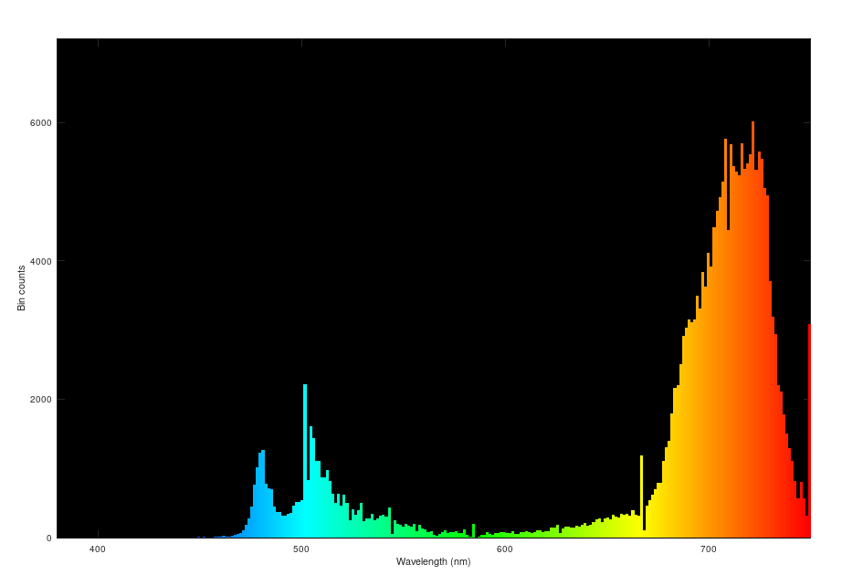Figure 7: Bar graph of histogram
My results did not compare well with the NASA results and were off by ~50 nm. This is unfortunate as, while I had never expected accuracy, I had expected it too be more similar than it turned out. The spectrograph I produced would be almost entirely useless and could be used for making only the crudest guesses regarding the composition of a nebula.
If I had to pick a theme of my project I would probably call it “Arbitrary Data Acquisition,” in part because of my recurring attempts to coax numbers out of this art project, but also because it seemed like a golden opportunity to use the word “acquisition.”
I chose these projects because I was unable to come up with an interesting collage to produce. Some briefly entertained ideas included stitching together various images of the same region (rejected because it turns out that most images of the same region are already pre-stitched together), overlaying different wavelength images onto each other to produce a composted image (rejected because most images with different wavelengths such as infrared that were not already combined), and combining various nebula images into a super nebula (which seemed dumb and also a much better project for photoshop). I suspect that the majority of the Hubble images are already edited to provide the best viewing experience and that any cropping, sharpening, or other effects I could apply would only worsen the images.
I also believe that what Matlab excels at is calculations, data interpretation, and data visualization. Having to read pages of documentation and multiple stackoverflow posts to preform tasks that would take 30 seconds in Photoshop seemed like an exercise in futility.
Bibliography:

- Globular Star Cluster
- Triangulum Galaxy
- Southern Crab Nebula
- Nasa spectroscopy
- Staco overflow post

